|  |
| --- |
| Progress Report |
| March 2025 |

|  |
| --- |
| A close up of a flower  Description automatically generated  Serpentine & Districts Golf Club Inc Clubhouse Upgrade Project |

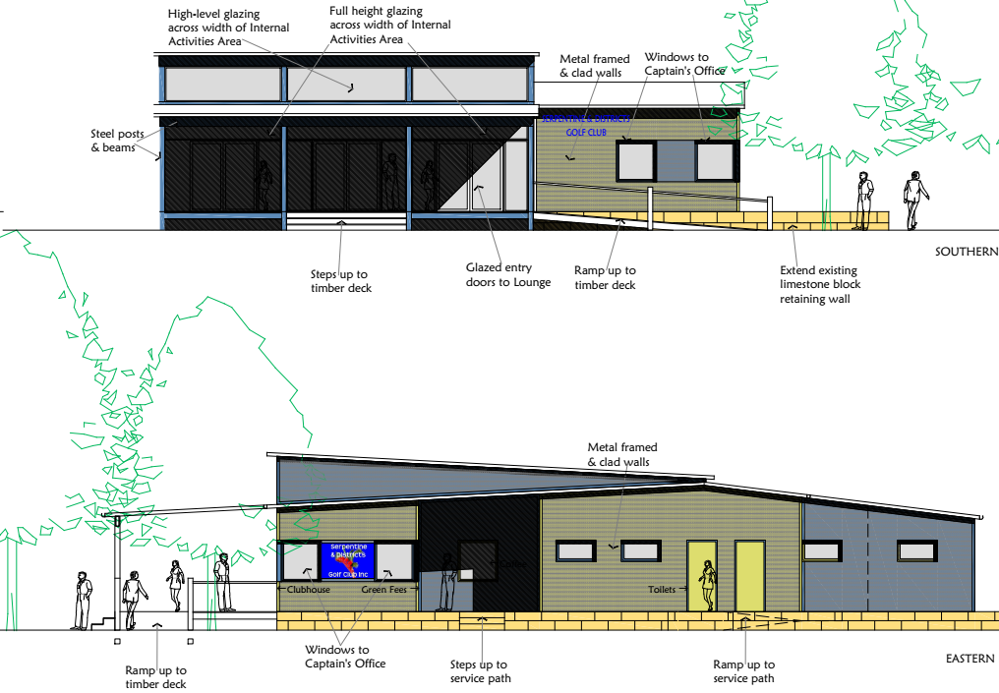

|  |
| --- |
| Progress Report |
| March 2025 Latest NewsTemporary Clubhouse We have secured a temporary Clubhouse building from the Donnybrook Tennis Club. This is a near new collapsable & transportable building and is 6m x 6.5m plus a verandah (see photos below).  A room with a table and a refrigerator  AI-generated content may be incorrect.  This will be placed along the western side of our undercover structure and will be sold when no longer required.  The captain’s office will be moved here, and it has a small kitchen to act as a tearoom. Social function will be held here with access to overflow areas provided by the verandah and existing undercover area. Temporary Toilets We have also secured a temporary portable toilet block. This will be put in place alongside the new effluent disposal system as soon as this has been installed. The block includes male and female sections with a total of 6 pans, a urinal and handbasins. New Effluent Disposal System Work has commenced on the preparation of the site for the new effluent disposal system, which is on the eastern side of the clubhouse. The EDS will be installed as soon as the Shire approval is received. The system will include a 150m2 disposal field that will become a feature garden on the eastern side of the clubhouse. Planning The pre-construction planning work is progressing well with temporary accommodation secured and site preparation works commencing. The application for building permit for the installation of the effluent disposal system has been prepared.    **Site Plan – Effluent Disposal System and Temporary Accommodation** Project Management Working Group The PMWG held a meeting on the 26th February. The agenda for this meeting included; Project Timetable, Costs, Funding, Design, Project Management, Project Risks and Contracts.  At this meeting it was agreed that we would work on achieving the option of completing the construction works in a single stage and contract over a 12-month period between July 2025 and June 2026. This is expected to reduce costs and will hopefully save several months in construction time. Building Approvals Once a building contractor has been appointed, they will be responsible for submitting the documentation for the Stage 1 building permit. |

# Costs

The estimated costs as of February 2025 are shown below;

# Funding

The total funding committed for the project has now reached the target amount of $840K incl GST

# 

# Timetable

With the positive outcome of the CSRFF application the required funding for the project has now been confirmed and the Club can now proceed with the project.

## Project Stages

The construction of the project has been split over a number of stages to manage the funding allocations and disruptions due building works.

The current timetable for these stages is shown below;



## 

# Site Photos

March 2025

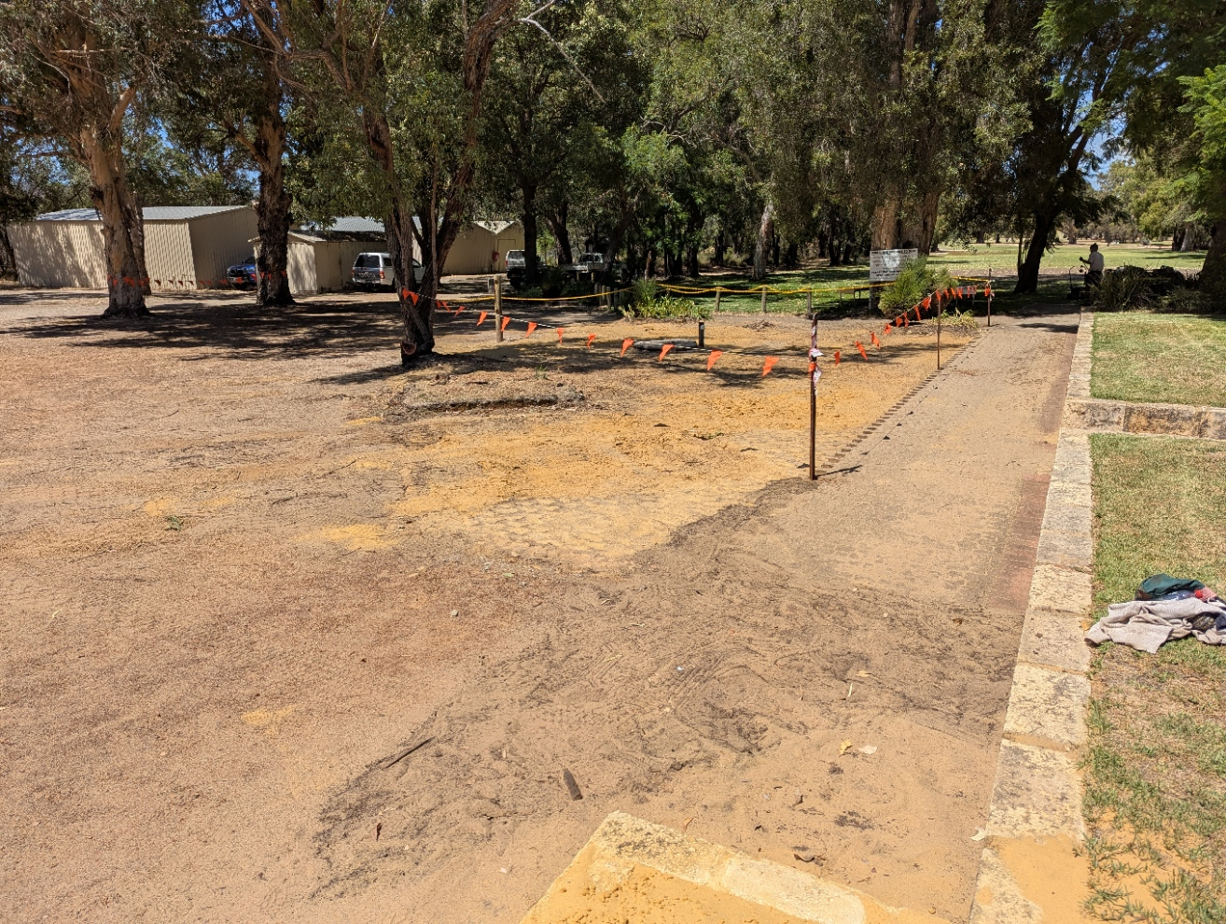

**Demolition Works – removal of old brick barbeque, brick paving & timber fence. This area is the location of the new effluent disposal system.**